**Part I – Creating Kernel Modules**

**\*\*\*\*\*\*\*\*\*\*\*\*\*\*\*\***

**First, enter the lsmod command on your Linux machine. What's the output on the screen? Answer: ________________.**

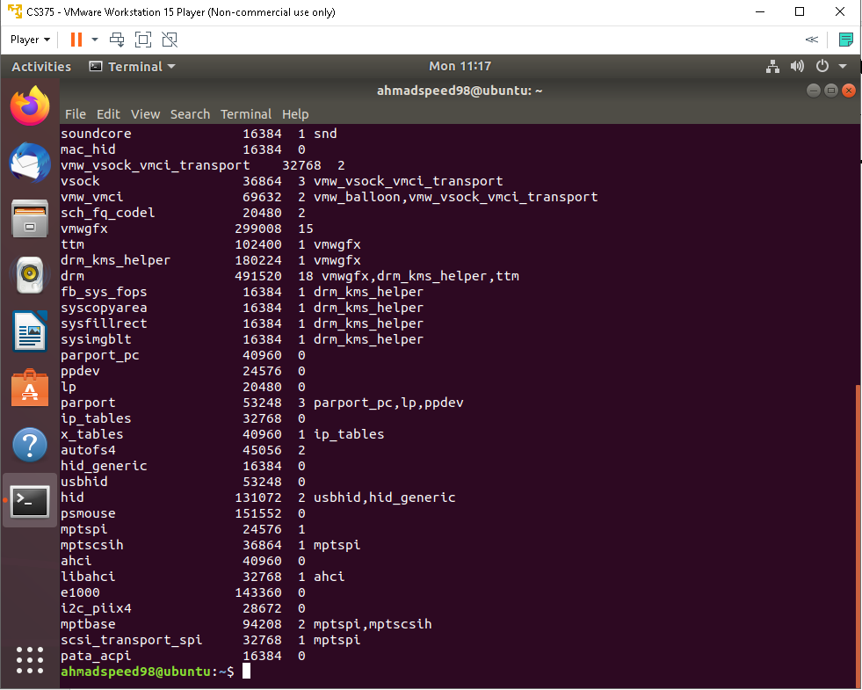

lsmod : display the status of modules in the Linux kernel

Use vi (or you can use gedit ) to create the following Makefile file.

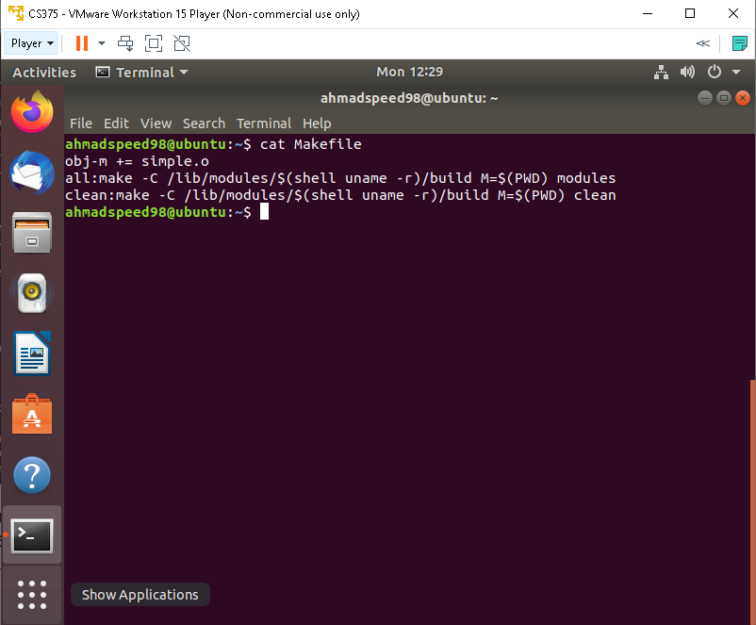

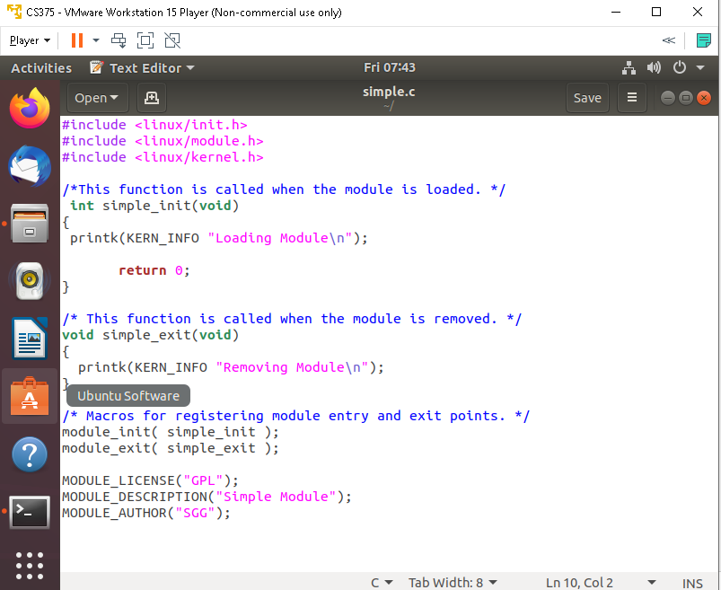

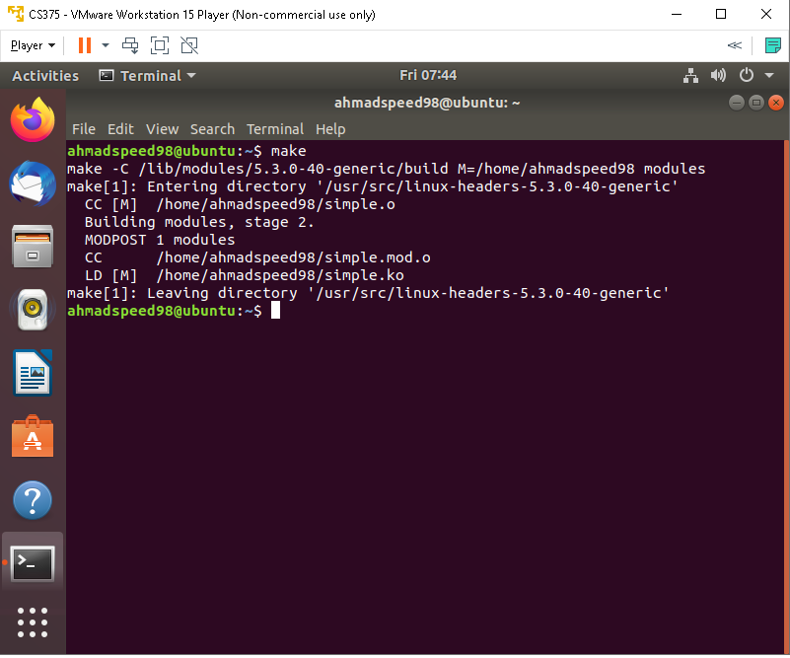

**The compilation produces several files. List all the files, and which of them represents the compiled kernel module?**

**Answer: _______simple.ko_________.**

**\*\*\*\*\*\*\*\*\*\*\*\*\*\*\*\***

**The following step illustrates inserting this module into the Linux kernel.**

**sudo insmod simple.ko**

**dmesg**

**What message do you see? Answer: ______**kernel ring buffer **__________.**

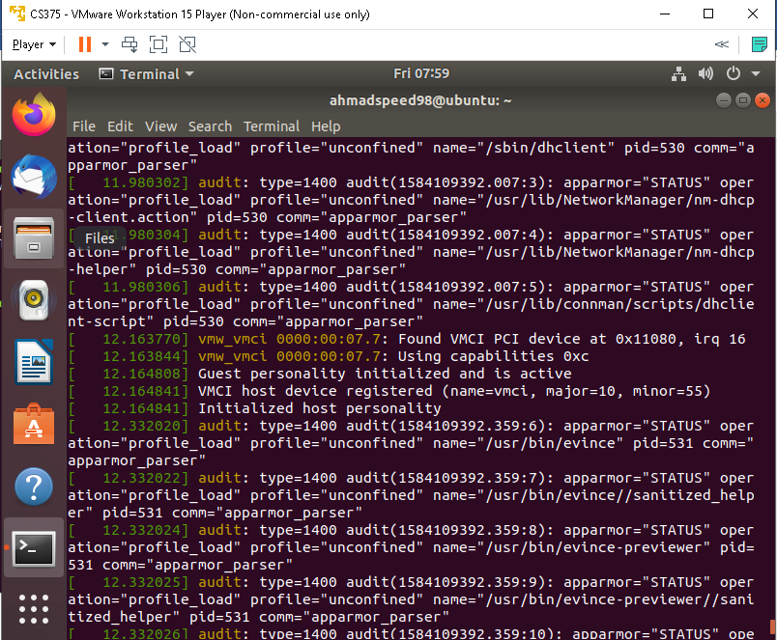

**\*\*\*\*\*\*\*\*\*\*\*\*\*\*\*\***

**Last, clear the kernel log buffer as follows: sudo dmesg -c**

**What is the purpose to clear the kernel log buffer?**

**Answer: _______ kernel log buffer can ﬁll up quickly because of that _________.** 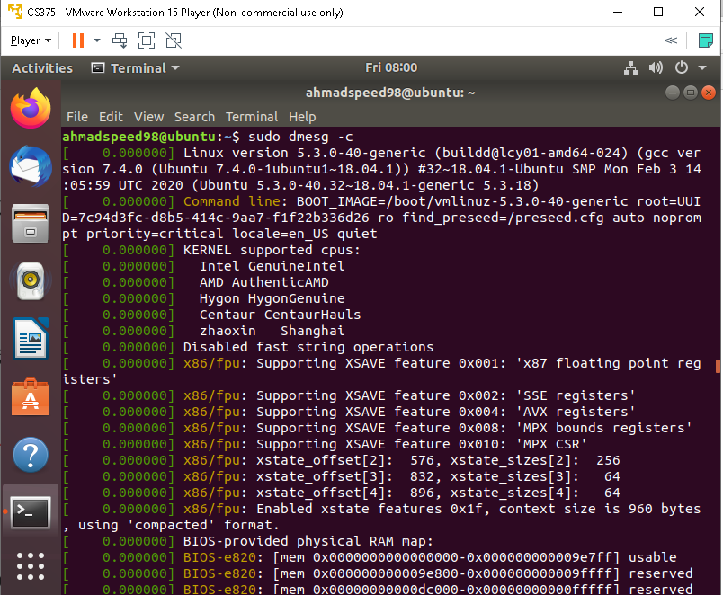

**Part II –Kernel Data Structures**

**\*\*\*\*\*\*\*\*\*\*\*\*\*\*\*\***

**Use vi (or gedit) to create the following the Makefile file.**

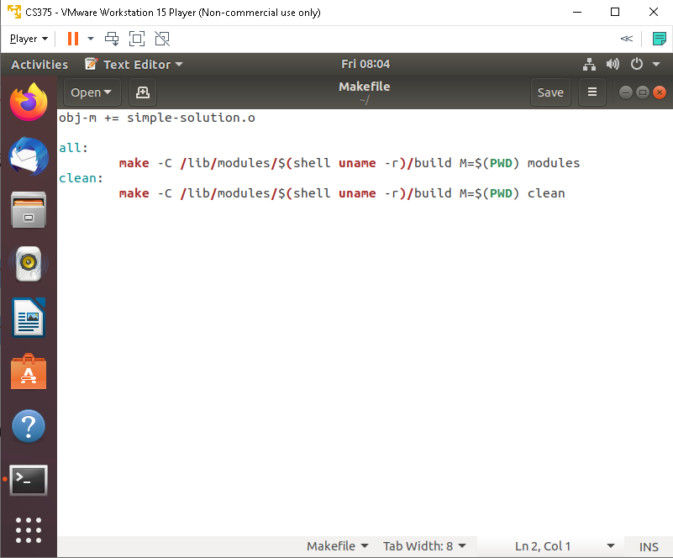

**\*\*\*\*\*\*\*\*\*\*\*\*\*\*\*\***

**Similarly, create the following program, named simple-solution.c using vi (or gedit).**

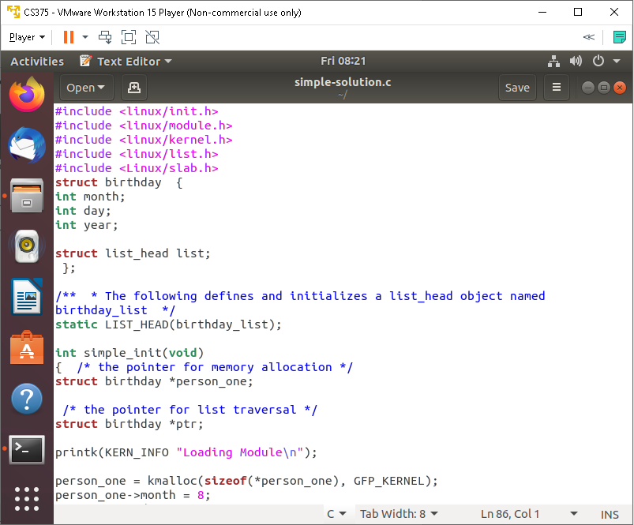

**\*\*\*\*\*\*\*\*\*\*\*\*\*\*\*\***

**Make**

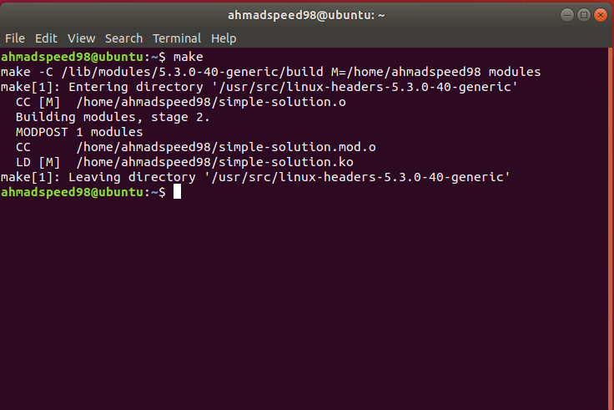

**\*\*\*\*\*\*\*\*\*\*\*\*\*\*\*\***

**sudo insmod simple-solution.ko**

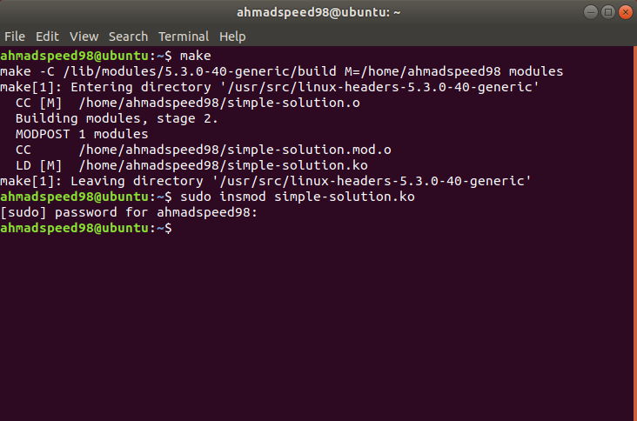

**\*\*\*\*\*\*\*\*\*\*\*\*\*\*\*\***

**dmesg**

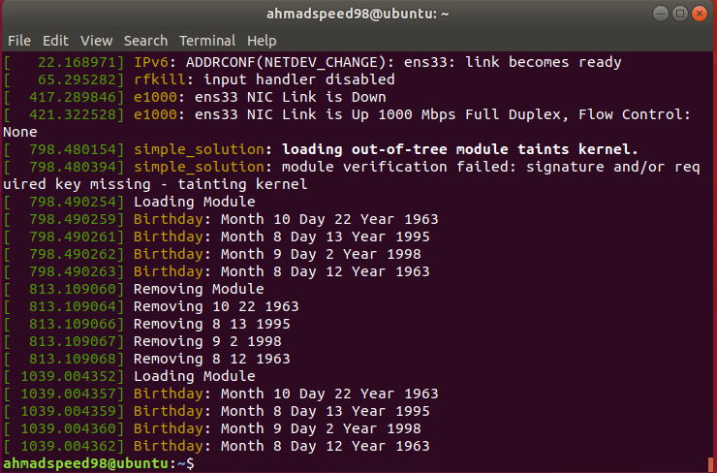

**In particular, what messages were output from the run?**

**Answer: ________** kernel ring buffer **________.**

**\*\*\*\*\*\*\*\***

**Removing the kernel module by**

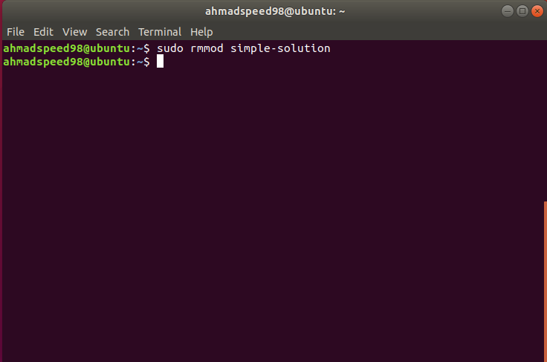

**\*\*\*\*\*\*\*\*\*\*\*\*\*\*\*\***

**Use the dmesg command to ensure the module has been removed.**

**Answer: ________________.**

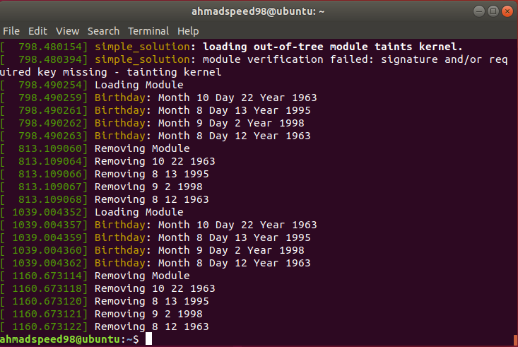

**\*\*\*\*\*\*\*\*\*\*\*\*\*\*\*\***

**Last, clear the kernel log buffer as**

